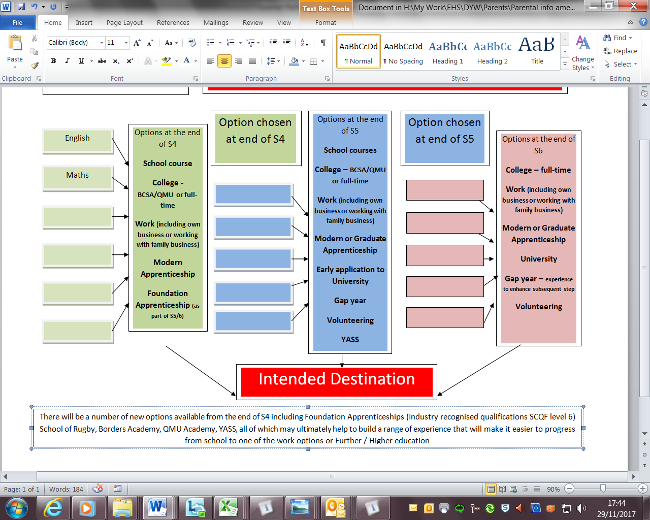

3 year plan from S4

**Options at end of S3**

**National Courses**

**Awards**

**BCSA courses**

**Specialisms in S3**

**English, Maths and 10 other subjects covering all curricular areas**

**Support** – Guidance teacher, careers advisers, class teachers, family, Pupil Support, help from employers and establishments, use of key websites, attend Open Days and information sessions

**Career Management** – self-awareness, research, ambition, awareness of opportunities, awareness of requirements for identified career options – skills and qualifications, exploring different routes into work, Learner Journey tasks, forward planning …

**Skills Development opportunities** – Clubs, community involvement, excursions, leadership role, awards, work experience, volunteering, enterprise activities, show, events, school support, part-time work… logging skills and evidencing development

5-year post-school plan?

**Career Plan B**

**Are you on track for success?**

Progression of Courses?

Coherent timetable?

Relevant courses and experiences?

Considering Routes and alternatives?

Accessing support and opportunities?

**1**

**2**

**3**

**4**

**5**

**Five years after school**

**Career Plan A**

Options chosen at end of S3

**Broad General Education in S1/2**

**Career Pathways/Learner Journey**