

A Guide for Business Partners


Excerpts from Developing the Young Workforce - - Work Placement Standard – September 2015
A modern standard should be established for the acceptable
content and quality of work experience, and guidelines should be made available to employers.
(Recommendation 3, Education Working for All, Commission for Developing Scotland’s Young Workforce Final Report, 2014)

Definition of Work Placement
Work placements should enable young people to experience a relevant, challenging, enjoyable and appropriate learning experience within the contemporary workplace. A placement should help the young person to make informed decisions about their future careers.
Work placements should adhere to a set of clear expectations for young people, employers, parents/carers, schools and local authorities on what work placements should deliver.

Work Experience Week for S3 students is in May each session
Information on this and other aspects of work-based learning can be found on the school career website at: http://earlstonhighschoolmyfuture.weebly.com/work-experience-week-for-s3.html

Expectation of Students for Work Placements

In advance of a placement:
• agree a placement that is mutually suitable them and the employer
• take ownership of the placement and have the opportunity to consider whether it is appropriate for career aspirations, ability and capabilities
• agree with the school and employer which goals to aim to achieve during the placement;
• understand the conditions of the placement regarding the expectations of the employer, including the importance of confidentiality
• take every opportunity using the main contact within the organisation and with the school, before embarking on my work placement, to become acquainted with any hazards
that may potentially occur when I am there.

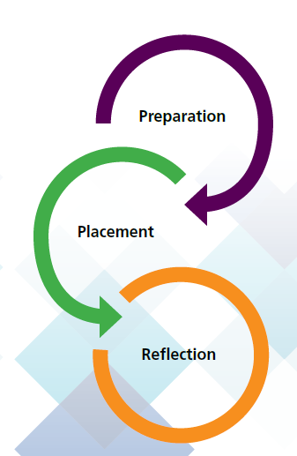
During placement:
• complete workplace learning plan and work toward achieving agreed goals and targets;
• demonstrate the behaviours and attitudes that the employer would expect to see in an exemplary employee;
• follow training and instructions provided by my employer and will wear any PPE provided
• take full advantage of the opportunities available t to develop my skills, gain knowledge and develop a positive attitude

After a placement:
• reflect on learning using placement experience
• reflect on feedback from employer and record it
• add relevant details of work placement to my CV
• share placement experience with school staff and peers, highlighting the skills acquired and opportunities available

Expectation of Employers for Work Placements

In advance of a placement:
• liaise with the local authority and/or school and the appropriate Regional DYW Group to promote opportunities;
• ensure that risks are controlled before the placement starts:
• ensure that the placement will take place at a time that is mutually suitable
• identify key member(s) of staff to support the young person
• know who the school/local authority link person is to support the young person
• be provided with, and consider, any information relating to the young person undertaking our work placement
• have agreed the targets with the young person
• ensure that the necessary admin is completed and returned to the school by the noted deadlines

During a placement:
• support the young person by providing appropriate training
• provide ongoing feedback to the young person
• offer a rich and varied experience which enables the young person to both understand the organisation, and to develop practical skills whilst undertaking meaningful tasks
• invite the young person to suggest ways in which our approach to work placements could be enhanced.

After a placement:
• take the opportunity to share views on the young person’s performance relating to their personal goals/targets with the school and young person
• receive and reflect on feedback from the young person and the school regarding the placement and experience

• take the opportunity to participate in a quality assurance survey

Recognition of Success

Earlston High School highly value work-based learning and we appreciate the importance of recognising related achievements. As well as continuing to offer a Work Experience award at our Celebration of Success Evening each March, we will also be giving our S3 students the opportunity to achieve an SQA Work Placement National Unit. The outcomes for this award are:
- Plan and complete a work placement
- Demonstrate appropriate behaviours and attitudes during the workplace
- Review progress and learning gained in the workplace

Each student will require supporting evidence to be successful with this and we would ask employers to support us in this regard in ensuring that the necessary paperwork is completed by students on placements and also by completing the required employer evaluations.

CONTACT

For any issues in connection with work-based learning (placements from S3-6, visits, events, projects, talks etc.) please contact David Ferguson, Principal Teacher – Developing Young Workforce

Phone: 01896-849282
E-mail: dferguson@scotborders.gov.uk





